

Newsletter Issue 01, November 2017
Safe-Guarding Home IoT Environments with Personalised Real-time Risk Control

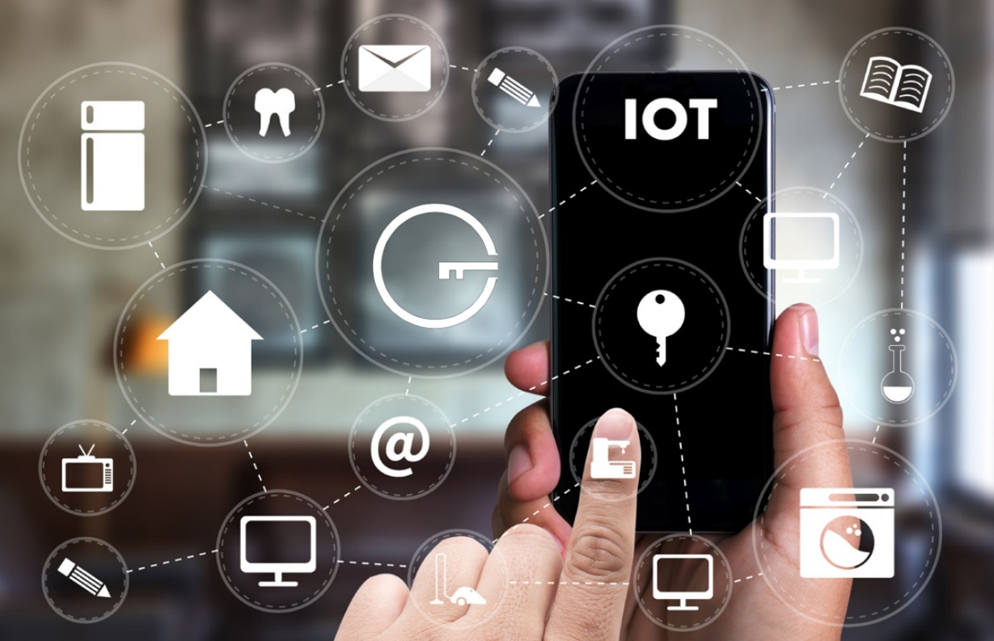
You can read GHOST’s newsletter on our website where it is also available for download.
Welcome to the GHOST newsletter, the first in a series that will be published every 6 months and serves as a fully accessible communication tool for the dissemination of the project’s important news, results and further steps.
Connect with us on social media:


EDITORIAL
Dear readers, welcome to the first issue of the GHOST newsletter.

GHOST is a 36-month European project, co-founded by the European Union’s Horizon 2020 research and innovation programme. The GHOST Consortium is highly interdisciplinary and multinational. It consists of ten experienced and committed partners, including four industrial partners, five universities, and one end user organization. The consortium is spread around six different European States (Spain, Switzerland, Germany, Norway, Greece and United Kingdom).

GHOST aims to deploy a highly usable and effective cyber security, risk assessment and privacy protection framework for Smart Home residents. GHOST will be embedded in the home network gateways to perform network analysis and deep packet inspection for suspicious pattern recognition, will apply machine learning and data analytics for malicious behaviour detection, will carry out context-aware real-time risk assessment, widely apply data analytics and visualisation for eﬀortless user comprehension and decision support, strengthen security defence through Blockchain technology and smart contracts, while ensuring interoperability with various gateways and a wealth of IoT devices through a dedicated middleware layer.
GHOST will be demonstrated and validated in real-life conditions at assisted living and regular private smart homes environments in Spain, Norway and Romania. These large-scale long-term trials are to be deployed in three phases through relevant high-level scenarios of escalating diﬃculty, with an overall duration of 10 months.
Enjoy reading and don’t forget to visit our website for more information.

Televes, GHOST project coordinator

Professor Erol Gelenbe from Imperial College London gave the Opening Keynote Lecture of the Cybersecurity conference at EuroCASE 2017, the annual meeting of the European National Academies of Engineering. The programme of the conference can be found at:
https://eurocase2017.psnc.pl/program/

Watch the full video of Erol's lecture at:
https://box.psnc.pl/f/84a39be3f9/
Consumers’ usable security
One of the dominant aspects of the GHOST platform is the use of a human centred by design approach to develop usable security and privacy protection solution. The end users will be involved in each development step to ensure iterative integration of constant refinement of the Control and Monitoring layer, a central end-user interaction component, based on the end-users feedback. User experiment studies will run in parallel with real-life scenarios to establish initial mental models based on human factors collected with user requirements. Based on these results the matching interfaces will be proposed, which will be reviewed and improved at every integration cycle.

Blockchain
Blockchain is a promising technology proposed for solving the distributed ledger problem in various scenarios. In GHOST its applicability for the securing core decision making component will be evaluated and integrated based on appropriate mining scheme selection. The resulting framework’s supplementary component will be efficient and resilient to attacks or malfunctions. Additionally, the smart contracts approach will be employed in order for the nodes to be able to cooperate in a way more elaborate than simple message exchanging. Nodes will take part in the execution of smart contracts which are codes that runs in a distributed and integrity preserving manner on multiple participants. The smart contracts will accept as input the observations of nodes about the system's integrity state and will enable distributed decision making about the appropriate actions, when a problem occurs.

Context aware security and privacy risk assessment
GHOST will act as a context aware risk assessment tool not only in terms of security, but also privacy control. Similar to a firewall, it will evaluate streams of data on the local network generated by IoT devices and apply heuristics for blocking undesired communications. In contrast to the default firewall behaviour where rules are predominantly rigid in nature (blocking on domain names, IP and port numbers), these heuristics will be dynamically based on the analysis of the data streams themselves. The data streams will serve as the input for building the context around the current communication, involved devices and the personal data of the end-user (recognition of activities and aggregation into behaviour pattern with his data). In addition, the risk evaluation rules engine will complement the GHOST platform with the ability for the end-user to monitor and control the associated risks and threats by blocking or allowing the communication to go outside of the local network.

Consortium news and updates
Key Technologies
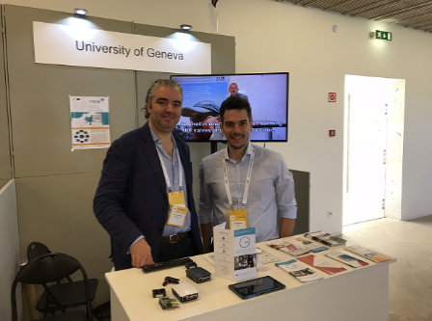
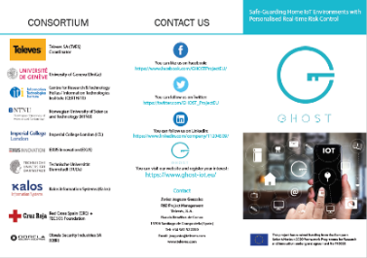
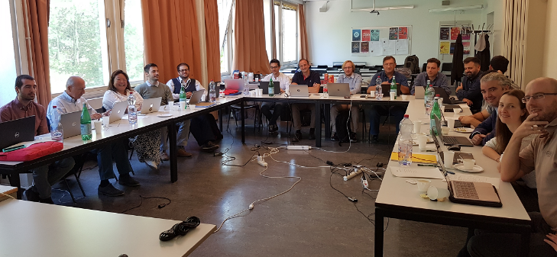
Between 2nd and 4th October 2017, GHOST project was represented in the international Active and Assisted Living (AAL) Forum 2017 in Coimbra, Portugal. GHOST was presented at University of Geneva’s booth in the exhibition hall of the forum by project members from Televes and University of Geneva who were there to meet people and gather feedback about the project, while also create new exploitation opportunities for GHOST. Flyers explaining the project were distributed for 3 days to interested participants, represent various potential stakeholders of the GHOST solution that include technology developers, policy makers and various types of end-user organisations. This event also offered the opportunity to the GHOST project members to network and build a stronger representation for the project. We look forward to the next AAL Forum, to present there the new developments and the integrated version of GHOST!
GHOST 1st plenary meeting
GHOST project’s first plenary meeting was organised and held by University of Geneva at their campus in Geneva, Switzerland during 4th and 5th September 2017. The meeting mostly focused on technical discussions and provided an opportunity for all the partners to provide progress updates of their technical tasks and modules particularly in WPs 3-6. Several important decisions were made and short tern actions and plans were agreed upon. Other discussions included project’s management issues, dissemination and communications progress and strategy, requirements gathering and real-life trials.

GHOST Kick-off meeting
The official kick-off for the European project GHOST took place in the Televes Corporation facilities, headquartered in Santiago de Compostela, Spain, on 2-3 May 2017. This event gave the partners the opportunity to meet each other and present their backgrounds and competencies related to their roles in the project. The Coordinator and the project officer presented an overview of the project plan and guidelines, respectively while individual WP leaders presented the rationale and setup of the respective WPs. Concrete plans were presented and agreed among partners regarding the active WPs and the overall project operational setup.
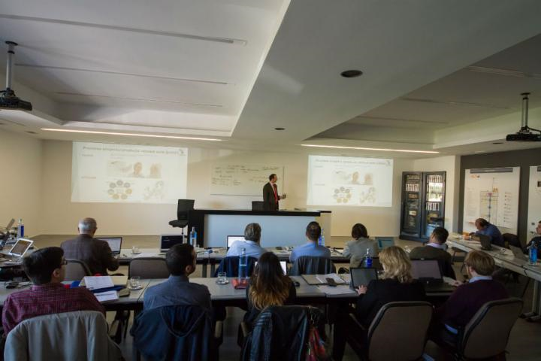

Dissemination activities:
Publications:

- Oksana Kulyk, Benjamin Reinheimer, Paul Gerber, Florian Volk, Melanie Volkamer, Max Mühlhäuser, “Advancing Trust Visualisations for Wider Applicability and User Acceptance”, 16th IEEE International Conference on Trust, Security and Privacy in Computing and Communications (TrustCom), August 2017.
- Benedict O’Donnell, “Blockchain making houses safer”, Horizon magazine, August 2017.

GHOST flyer:

Project News & Events
How will GHOST leverage the pathway to the market?

The partners that compound the GHOST consortium share a common view of the R&D ecosystem: the innovations created in the framework of the project must be as close as possible to the market. Due to this shared vision, the project has included specific mechanisms to test the solution under real circumstances, to leverage the pathway to the market and to sustain the business models for the results of the project. These mechanisms include a specific iterative User Centred Design methodology that enables the participation of the end-user in the creation process, the inclusion of specific measurements and indicators and the realization of several real-life trials in different countries and with different testing scenarios.
For that, the validation strategy defined for the project is based on a two-fold vision that combines the specific definition of test beds and real-life trials or pilots. First, two specific testbeds have been designed in the facilities of the members of the consortium (specifically, in Televes and CERTH) to deeply test the functionalities of the GHOST solution in a non-critical environment, avoiding leakage or security risks. In addition to these testbeds, the participation in the project of organizations with tight contact with final end-users (particularly, Spanish Red Cross and Kalos Information systems) allows the definition and setting up of a set of pilots in real scenarios (homes of end-users) in three different countries (Spain, Romania and Norway) and with complementary use cases related with telecare, eHealth, home security and home automation, in order to get the specific feedback of the end-users regarding the security solution without compromising their security.
It should be noted that, the testbeds designed for Televes Showroom and CERTH Smart Home include more than 15 different types of devices, involving up to 25 devices. These devices will be simultaneously connected and monitored by the GHOST suite that will extract the patterns of the devices and look for possible behaviour deviations during unit and integrated testing of the different modules of GHOST. In order to have a broad view of the possible services and solutions, devices like smart locks, biomedical devices, companion robots or smart lights including several communication solutions (like 802.11, 802.15.4, Z-Wave or Bluetooth Low Energy) have been included in the testbed definition.

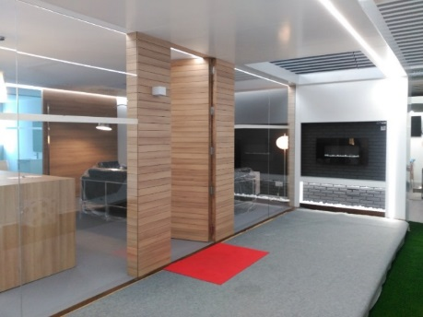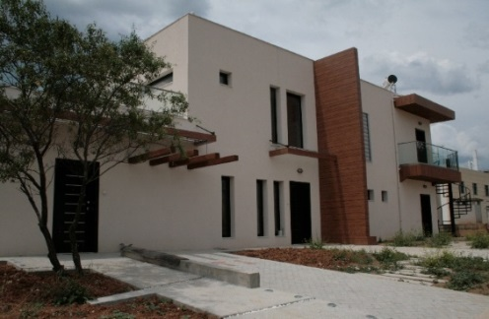
TELEVES and CERTH’s testbed facilities

The real-life trials have been designed to cover a varied set of applications and services, related with the expertise of the partners. Thus, four different use cases have been defined as follows:
- Use case 1 – Ambient assisted living in smart homes for older people: this use case will involve 50 users (25 beneficiaries older than 65 years old and 25 caregivers, in 25 homes) in Galicia, in the northwest of Spain. The specific characteristics of the region, with a highly aged population, makes this region a perfect place to test advanced IoT enabled telecare services and the relevance of security for these kind of users.

- Use case 2 – Continuous health monitoring for adult people: this use case will involve 50 users (25 direct beneficiaries between 40 and 64 years old and 25 relatives, in 25 homes) also in Galicia. The main objective of this use case is to test the influence of security interventions and decisions in a remote health monitoring solution, in which users with chronic diseases such as hypertension, obesity or diabetes improve their conscience about the importance of taking care of their affection.

- Use case 3 – Regular private homes (smart-home solutions) in Norway: in this case, the objective will be to integrate and test the GHOST solution with traditional smart home services such as energy monitoring and saving, and home security, among others. In this specific use case, the selected regions will be Førde in the west of Norway and with a ratio of 2, 3 inhabitants per home, being a perfect spot for testing the solution in regular homes. This trial will involve 20 homes, reaching up to 50 users.

- Use case 4 – Regular private homes (smart-home solutions) in Romania: this use case has the same technical scope as the Norwegian one, but it will be located in Bucharest (Romania). The main difference between these two use cases is the demographic and climate differences between the two regions, with Romania having a bigger population density and warmer temperatures (in general). This trial will also involve 20 homes, reaching up to 50 users.

Each use case will have its own set of devices to be installed and a complete test plan will be developed to simulate the possible results of specific attacks (previously validated and performed in the testbeds) to get the response of the user to the GHOST behaviour. More information regarding the definition of the use cases, the specific regions and the devices to be installed and tested in each of the cases, can be found in deliverable D3.9 (placed in the Results & Documents section of the website). In addition, the information for the validation process will be updated throughout the project duration.
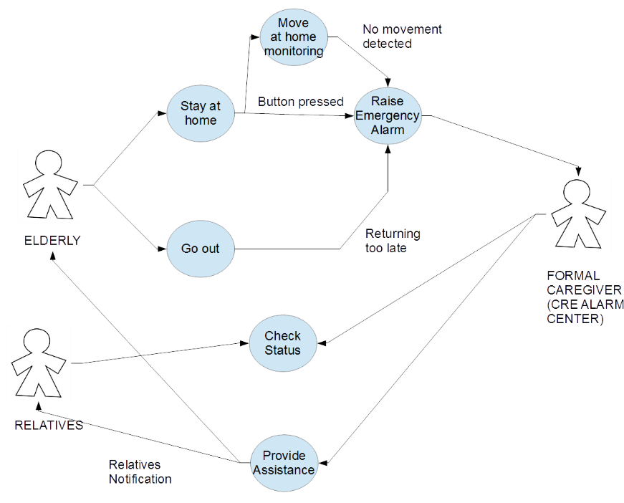
Basic UML-model of Use Case 1

10 partners (plus one third party) from 6 countries
GHOST Consortium





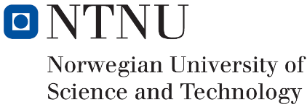


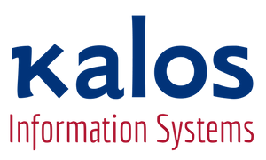



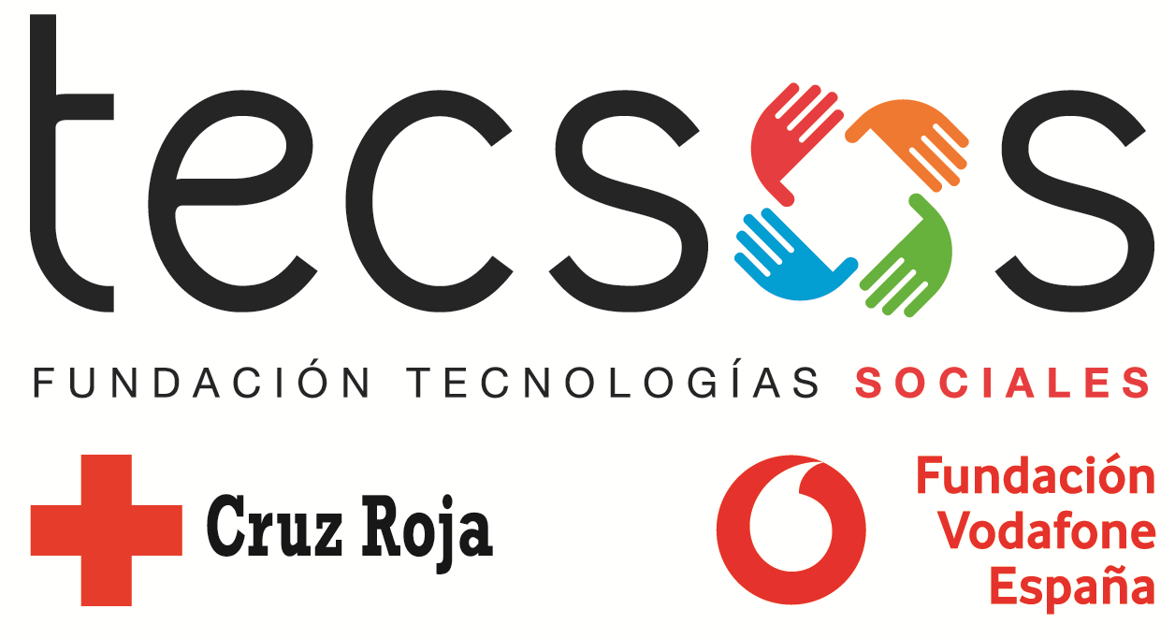

Looking for more information about GHOST?
Contact info:
Javier Augusto Gonzalez
Televes
GHOST project coordinator
jaugusto@televes.com
Visit our website at: www.ghost-iot.eu
Connect with us on social media:

